Chapter 6

**CNN ColorNET**

**6.1 Online Mode**

If farmer has internet it will be in online mode. Then the farmer will take picture keeping the leaf on the hand. Then the app will segment the leaf according to it.

**6.2 Segmentation**

When the farmer take picture keeping leaf on hand smart device will segment out the leaf from hand.

Full Image with hand

Convert to HSV in skin color range

Detect contour

Find the leaf with 2nd biggest contour

and mask the image

Output only leaf

Draw convex hull

Range the green shade

Segment the convex hull and musk the image

Figure 3.12: Segmentation overview

Segmentation process

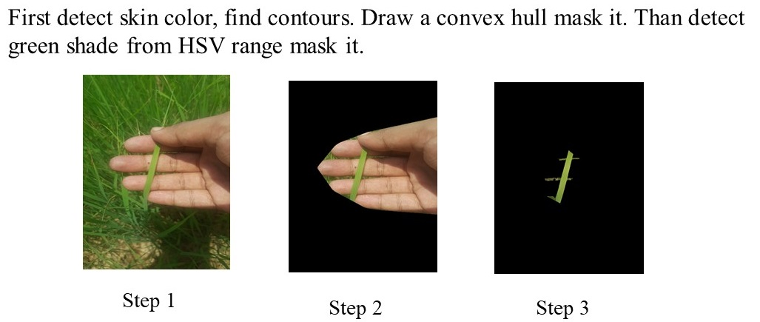

Figure 3.13: Segmentation process

**6.3 Color Net (CNN Model)**

Convolution model is using exiting color net model [3]

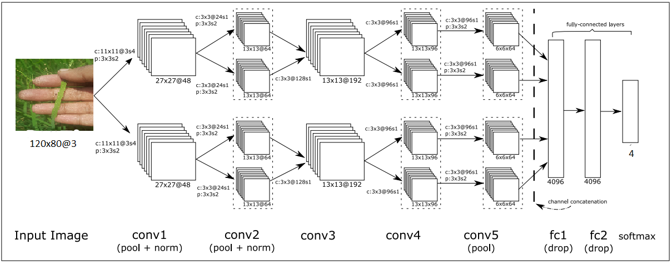

Figure 3.14: Color net model

Training the Color net model with our ideal data for leering the color of different labels at different lighting condition and different time.

Learning 30 Epochs

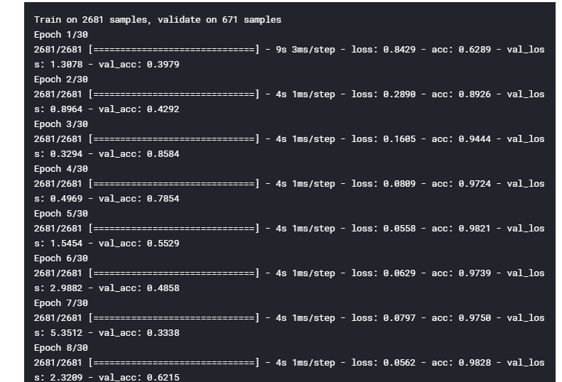

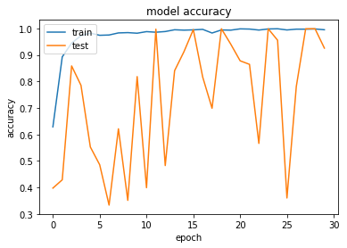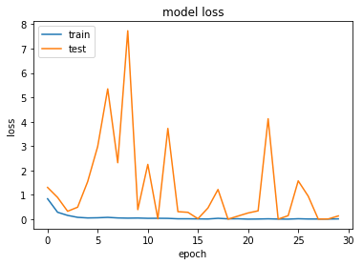

Figure 3.15: Per epochs history

At epoch 24 we get higher validation accuracy. Almost 100% accuracy.

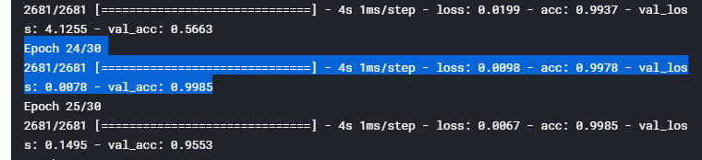

Figure 3.16: Accuracy of the model

Full overview of the model

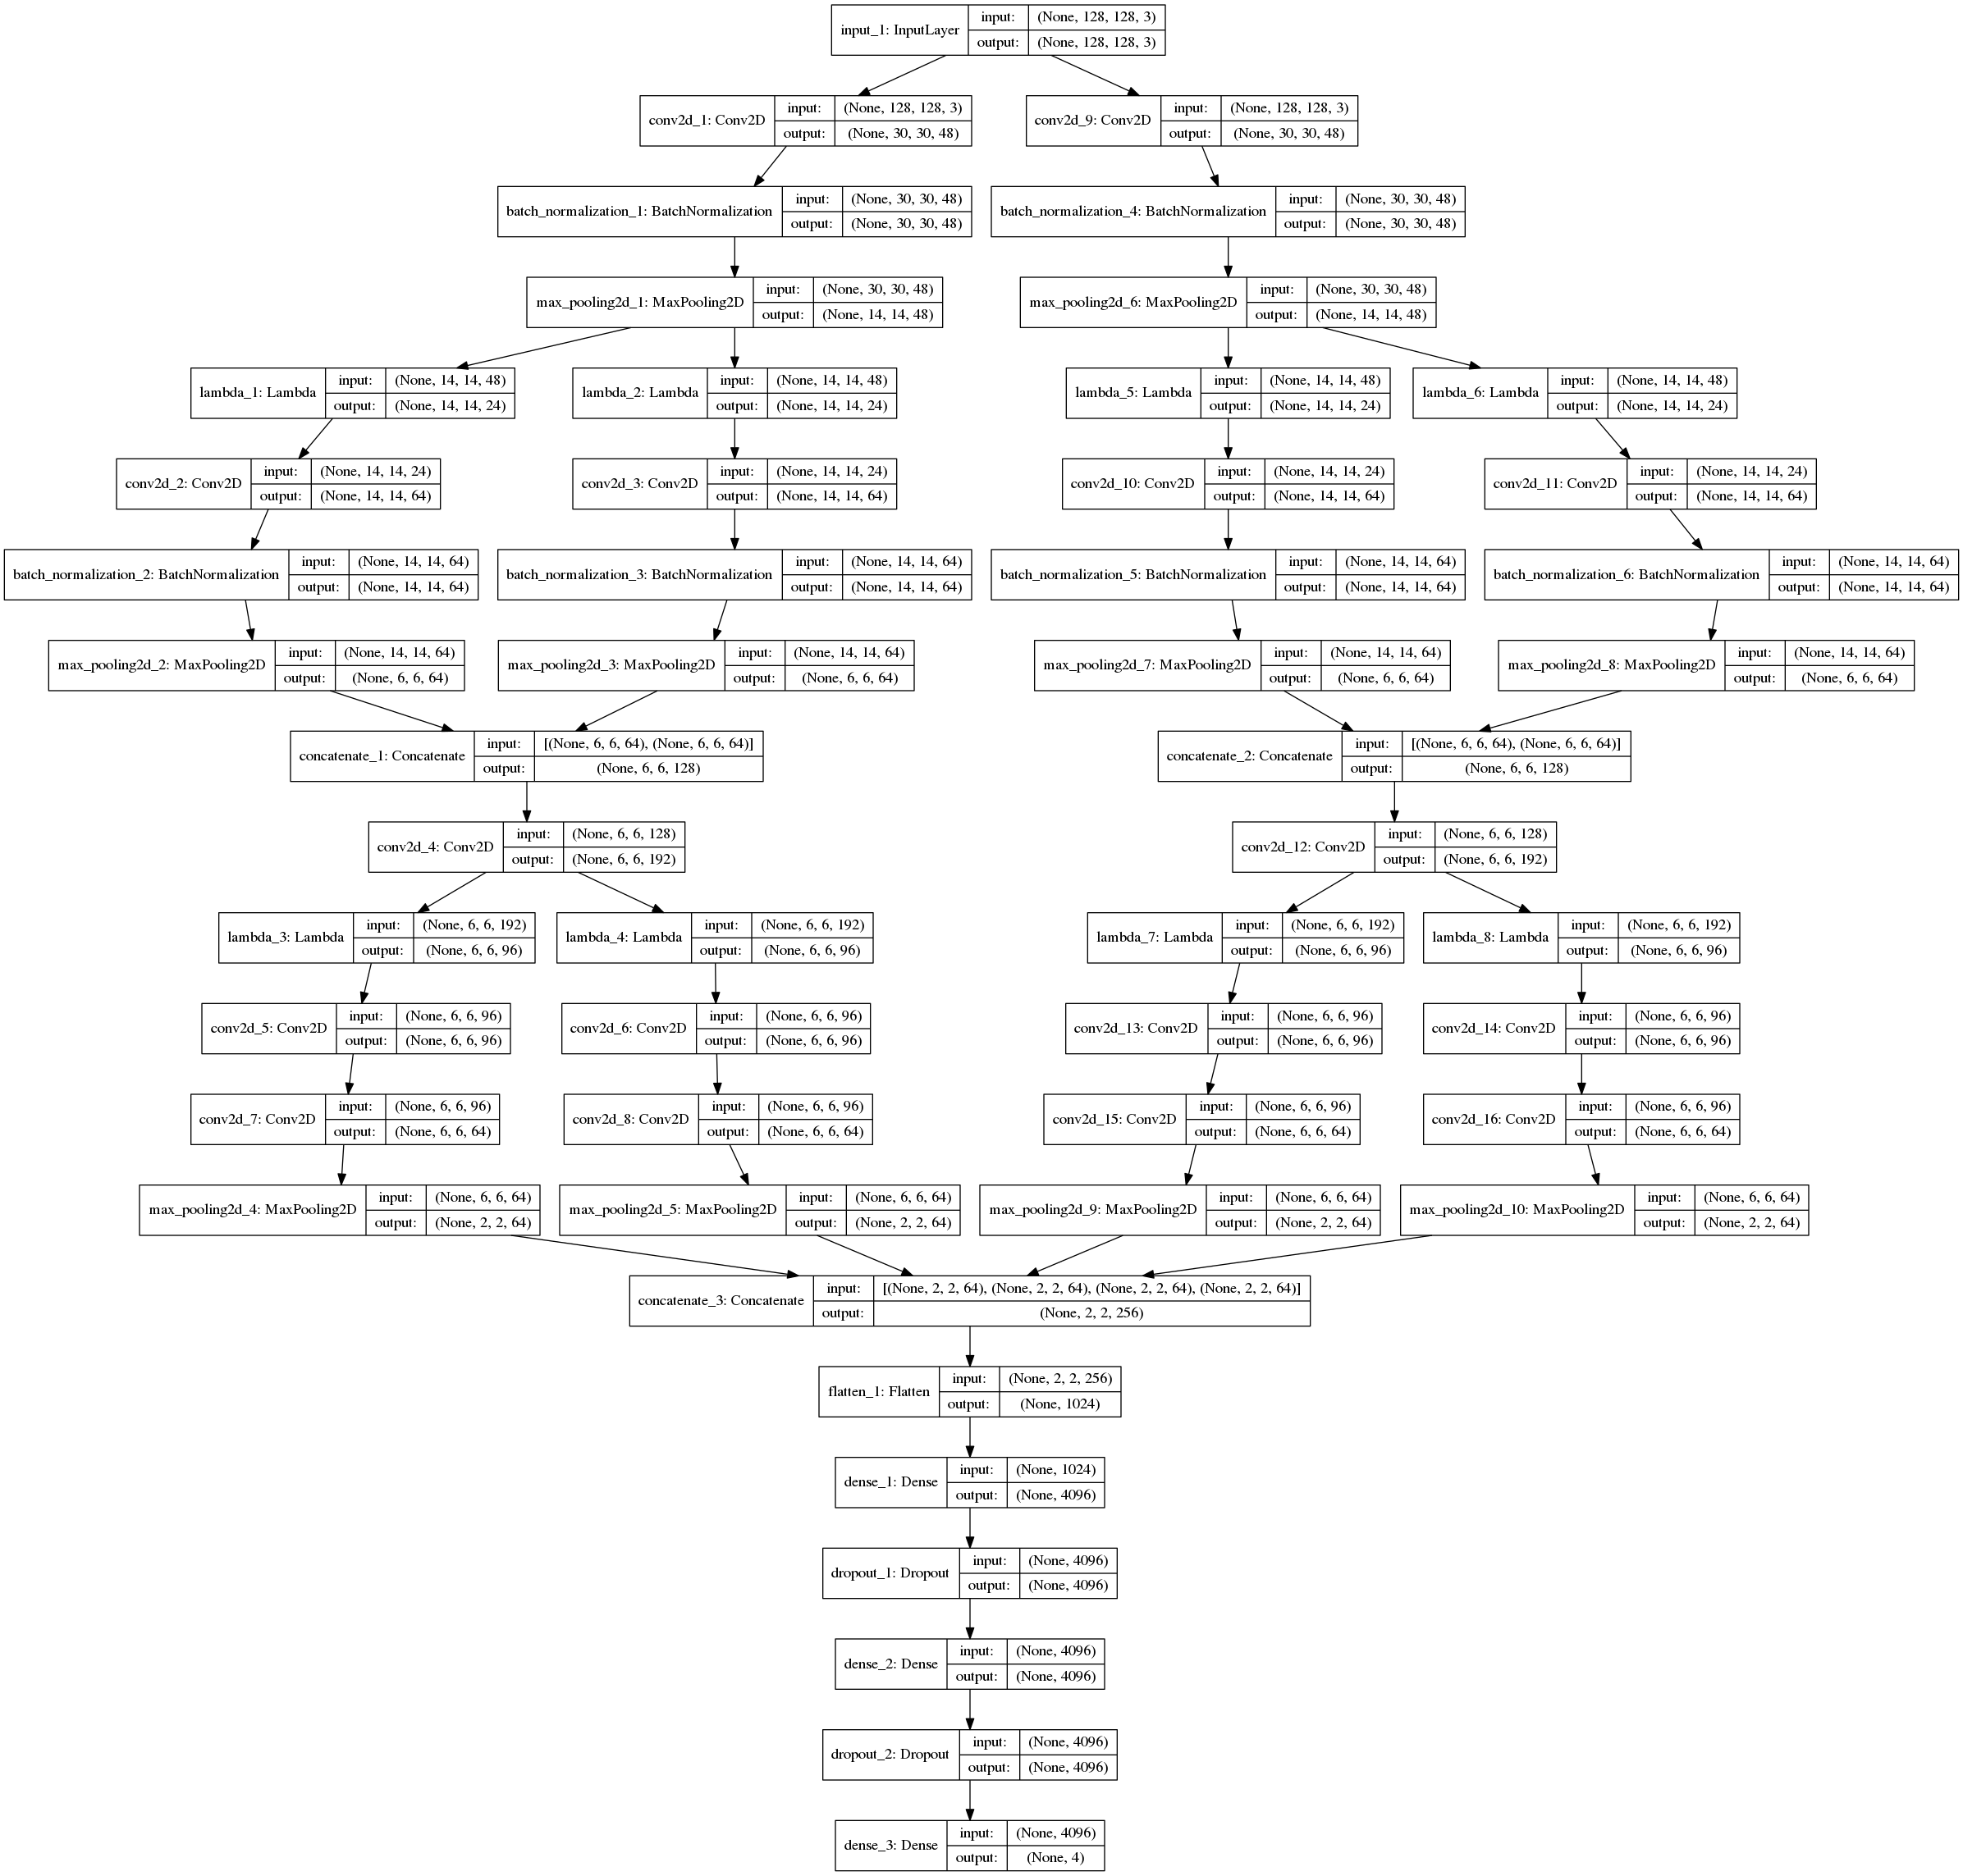

Figure 3.17: Full layers of the Color net model

Application using API data flow

Leaf on hand

API call to server

Segmentation

Input paddy field area

Output fertilizer amount

High performance computer

Send result

Run Keras model

Figure 3.17: Data flow diagram